Lesson 03

Overview
In this worksheet, we explore the principle of Separation of Concerns (SoC) - a foundational concept in software design. SoC encourages structuring a program into distinct sections, each responsible for a specific concern, such as business logic, user interface, database access, or security.
A common implementation of SoC is the Model-View-Controller (MVC) architecture.
Before you attempt the questions in this worksheet, you should go through the respective topics in your notes:
Worksheet | Notes
Section A | Separation of Concerns
Section B | AI Assisted Coding
Section C | Supervised Refactoring
Section D | CA1: Code Check-in and AI Journal
Section E | Submissions

Do seek your lecturer’s advice when in doubt

Section A – Separation of Concerns

Exercise 1
In your teams, discuss what different responsibilities does app.js in PetCareApp handle? Give one example of each.
Handles the
Presentation: Display 3pet profiles and journal entries using EJS views.
Request handling: Process form submissions and choose the response or redirect.
Data access: Retrieve and save pet and journal records in MYSQL.
Access control: check login status and restrict admin pages to administrators.
File uploads: Handle pet photos with Multer and save them in public/images.
Configuration: Manage the database connection settings and credentials.

Exercise 2
In your teams, discuss how you would reorganise the Add a New Pet feature using MVC. Identify the responsibilities of the Model, View and Controller, and explain how routes connect requests to the controller. Keep the feature’s existing behaviour unchanged.
Component | Guiding question | Team’s response
Model | What database operations should this component handle? | Inserts the pet details into the database, linked to its owner. Return the results or error to the controller
View | What should the form display and allow the user to enter? | Display the Add Pet form with fields for name, species, breed, age, and an optional photo. Show validation error messages when needed.
Controller | How should this component process the submitted data and decide what response to send? | Display the form when requested. On submission, read and validate the pet details, obtain the owner ID from the logged-in user’s session, and call the model to save the pet. Redirect on success or display an error on failure.
Routes | Which requests should connect to which controller functions? What middleware is needed? | Connect the GET request to the controller function that displays the form, and the POST request to the function that processes it. Apply the login-check middleware and upload middleware for the photo submission.

Section B – AI Assisted Coding
Exercise 3
Open PetCareApp MVC Refactoring* Specification.docx. In your teams, study the document and complete the table below. Do not ask AI to edit the project yet.
Be ready to explain one proposed code move and one behaviour that must remain unchanged.
Focus | Questions to discuss | Team’s Response
Purpose | What is the specification asking you to change? Explain “structural refactor” in your own words. | To reorganise the codes into MVC
What must stay unchanged | Identify four behaviours that must be preserved. Why is preserving them important? | The route methods and URLs, the login and logout flow, the admin access checks, and the error and access-denied responses. Preserving them is important as it ensures users can complete the same tasks and helps us detect unintended changes caused by the refactor.
Responsibilities | Choose the Add a New Pet feature. Where should its routes, request handling, SQL and form belong after refactoring? | Routes: Map the existing GET/POST requests to controller function and retain their middleware. Controller: handle the request, call the model and send the response. Model: execute the SQL that saves the oet, view: Keep the existing EJS dorm and template variables unchanged
Constraints | Identify two changes that are explicitly prohibited. Why might an apparently helpful “improvement” be outside the scope of this task?
Evidence of success | Propose three checks you would perform to confirm that the refactored application still works as before.
Questions or concerns | Identify any requirement you do not understand or need to check against the existing code.

Section C – AI Assisted Coding
Exercise 4
- In your C372 VS Code workspace, create a new folder named Week02.
- In the Resources folder provided to you, you should find a folder named PetCareApp
- Right click on PetCareApp folder and copy this folder. (Ctrl-C)
- Go to Week02 folder in VS Code and paste PetCareApp into Week02 folder. (Ctrl-V)
- Check that PetCareApp is within Week02 folder. It should look similar to the screenshot here.
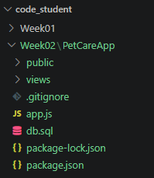
Exercise 5
To enhance the quality of results, it's important to provide relevant context. For this exercise, that means including details from the PetCareApp project.
- Right-click on the folder PetCareApp within Week02 folder
- Select Add Folder to Chat
Once added, you should see the PetCareApp project added as shown here.
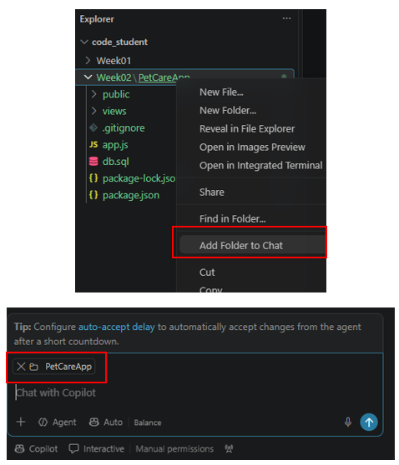

Exercise 6
Write a prompt asking Copilot to analyse the PetCareApp project and explain how the Add a New Pet feature works. Use the Ask mode.
What to record | Response
Original prompt | please analyse the PetCareApp project and explain how the add a new pet feature works
Context provided | vvv
Key findings from Copilot
Two claims we checked, with code references
What was missing, unclear or incorrect?
Revised prompt and what improved

Exercise 7
- Push your code to Github (Make it a habit to do so regularly at appropriate times.)
- Right-click PetCareApp from Week02 folder, Select “Add Folder to Chat”
- Copy the specifications from PetCareApp MVC Refactoring Specification.docx and paste it into GitHub Copilot.
- Change to Agent mode in the chat
- Submit the prompt
- Observe the output. It should show you:
  - An inventory of the existing routes and behaviour
  - Proposed MVC folder structure and file mapping
  - A staged migration plan
Do not approve any edits yet.
Although it is in Agent mode, it still stops before editing the files to check for you approval. Why?

Exercise 8
Review Copilot’s proposed plan against the specification and existing code.
Do not approve any edits yet.
Complete the checks below and record evidence for your decision.
Check | What to verify | Evidence
Route accuracy | Choose one route. Do its HTTP method, URL and middleware match the existing code?
MVC responsibilities | For Add a New Pet, does the plan correctly separate routes, request handling, SQL and the form?
Scope | Does the plan preserve existing behaviour and avoid adding features or unrelated improvements? Identify any omissions or concerns.
Migration steps | Does the plan break the refactor into manageable stages with checks before proceeding?
Readiness | Have you recorded the current behaviour and created a backup or Git checkpoint?

Exercise 9
Depending on your earlier response in the previous exercise, make your decision:
- Approve: The plan matches the specification and your checks support proceeding.
- Request corrections: You found a specific error, omission or out-of-scope change.
- Ask for clarification: Part of the plan is unclear or lacks enough detail to verify.

Exercise 10
After resolving concerns, approve the first stage. Review the changed files and test that stage before allowing Copilot to continue.
- Right-click on PetCareApp in Week02 folder, select Open in Integrated Terminal
- Run the command: npm install
- Run the command: node app.js
- Use the MVC refactor verification checklist to check that all features work as expected.
- If there are errors, or unexpected behaviour, copy the error or describe the issue to copilot.
MVC refactor verification checklist
Check | What to verify | Done
Responsibilities are separated | Routes map requests, controllers handle requests and responses, models contain SQL, and views contain EJS presentation code.
Routes remain consistent | HTTP methods, URLs and middleware order match the original application.
Existing features still work | Test login/logout, pet selection, search, journal add/edit/delete, and adding a pet with a photo.
Access controls still work | Regular users cannot access admin pages. The admin walkthrough succeeds.
The refactor stays within scope | No unintended changes to the database schema, redirects, uploads or existing behaviour.

Section D – CA1: Code Check-in and AI Journal
Use this section to check in your PetCareApp code and begin documenting your AI-assisted work in the CA1 AI Interaction Journal.
Before continuing, ensure your latest PetCareApp work is committed and pushed to your GitHub repository. Record your prompts, the context provided, AI responses, checks performed, decisions made, and any corrections in your journal.
Exercise 11 — Start Your AI Interaction Journal
Open the PetCareApp project that you worked on in Section B.
- Check that PetCareApp runs and its existing features still work.
- Save your latest changes.
- Begin documenting your work in the CA1 AI Interaction Journal.
- Include evidence of your prompts, AI responses, verification, decisions, and corrections.

Document your work in the file:
C372 Individual CA1 AI Interaction Journal – STUDENTID – STUDENTNAME.docx

Fill in the sample logins
(Check db.sql for the login info)
Role | Username | Password
Admin
User

Exercise 12 — Check In Your Code
- Create a public GitHub repository if you have not already done so.
- Commit and push your latest PetCareApp code to your own GitHub repository.
- Fill in the form with your GitHub repository URL
C372 Student CA Individual GitHub Repository – Fill out form

Section E – Submissions
Deliverables for today
- Worksheet (Individual)
- Upload your deliverables to POLITEMALL even if it is incomplete before the next session.
- You can resubmit by 2359 if there are updates.

SA3.0 (CA 1 Interim submission)
This also serves as a backup submission.
- PetCareApp project code (Individual, zipped)
- C372 Individual CA1 AI Interaction Journal – STUDENTID – STUDENTNAME.docx

